**Day 7**

1. Rank employees by their total sales

(Total sales = Total no of orders handled, JOIN employees and orders table)

**Query:**

SELECT

E.EMPLOYEE_ID,

COUNT(ORDER_ID) AS TOTAL_SALES,

RANK() OVER (ORDER BY COUNT(O.ORDER_ID)) AS SALES_RANK

FROM

ORDERS O

JOIN EMPLOYEES E ON E.EMPLOYEE_ID = O.EMPLOYEE_ID

GROUP BY E.EMPLOYEE_ID;

**Output:**

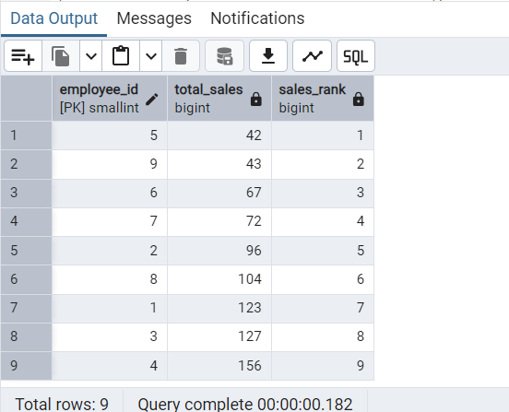

2. Compare current order's freight with previous and next order for each customer.

(Display order_id, customer_id, order_date, freight,

Use lead(freight) and lag(freight).

**Query:**

SELECT

ORDER_ID,

CUSTOMER_ID,

ORDER_DATE,

FREIGHT,

LEAD(FREIGHT) OVER (PARTITION BY CUSTOMER_ID ORDER BY ORDER_DATE DESC ) AS FREIGT_LEAD,

LAG(FREIGHT) OVER (PARTITION BY CUSTOMER_ID ORDER BY ORDER_DATE DESC) AS FREIGT_LAG

FROM

ORDERS;

**Output:**

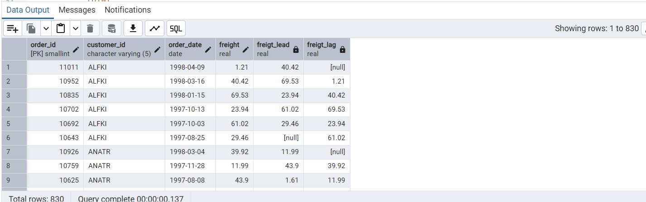

3. Show products and their price categories, product count in each category, avg price:

(HINT:

· Create a CTE which should have price_category definition:

WHEN unit_price < 20 THEN 'Low Price'

WHEN unit_price < 50 THEN 'Medium Price'

ELSE 'High Price'

· In the main query display: price_category, product_count in each price_category, ROUND(AVG(unit_price)::numeric, 2) as avg_price)

**Query:**

WITH cte_price_category as(

SELECT

product_name,product_id,category_id,

unit_price,

CASE

WHEN unit_price < 20 THEN 'Low Price'

WHEN unit_price < 50 THEN 'Medium Price'

ELSE 'High Price'

END as price_category

FROM products)

SELECT

price_category,category_id,

COUNT(product_id),

ROUND(AVG(unit_price)::numeric, 2) as avg_price

FROM cte_price_category

group by

category_id,price_category

order by category_id;

**Output:**

